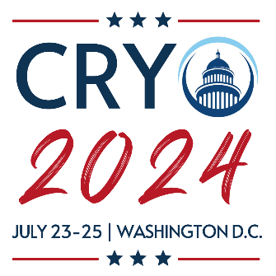
ANNUAL MEETING SYMPOSIUM PROPOSAL
Please send this symposium proposal to admin@societyforcryobiology.org

Symposium Details
Title:
Description: (Aim & Scope)
Organizer: (Name, email, affiliation)
Slot time required: (90 or 120 minutes)
Chair or Co-chairs:
SPEAKER 1 DETAILS
Name:
Email:
Affiliation:
Brief Bio:
Proposed Presentation Title:
Have they already agreed to present?
SPEAKER 2 DETAILS
Name:
Email:
Affiliation:
Brief Bio:
Proposed Presentation Title:
Have they already agreed to present?
SPEAKER 3 DETAILS
Name:
Email:
Affiliation:
Brief Bio:
Proposed Presentation Title:
Have they already agreed to present?
SPEAKER 4 DETAILS
Name:
Email:
Affiliation:
Brief Bio:
Proposed Presentation Title:
Have they already agreed to present?
SPEAKER 5 DETAILS
Name:
Email:
Affiliation:
Brief Bio:
Proposed Presentation Title:
Have they already agreed to present?
SPEAKER 6 DETAILS
Name:
Email:
Affiliation:
Brief Bio:
Proposed Presentation Title:
Have they already agreed to present?

